Name: Shivathmika V
Reg No: 192521028
Date:06-08-2026
CSA1204 Lab work
8 Bit Addition

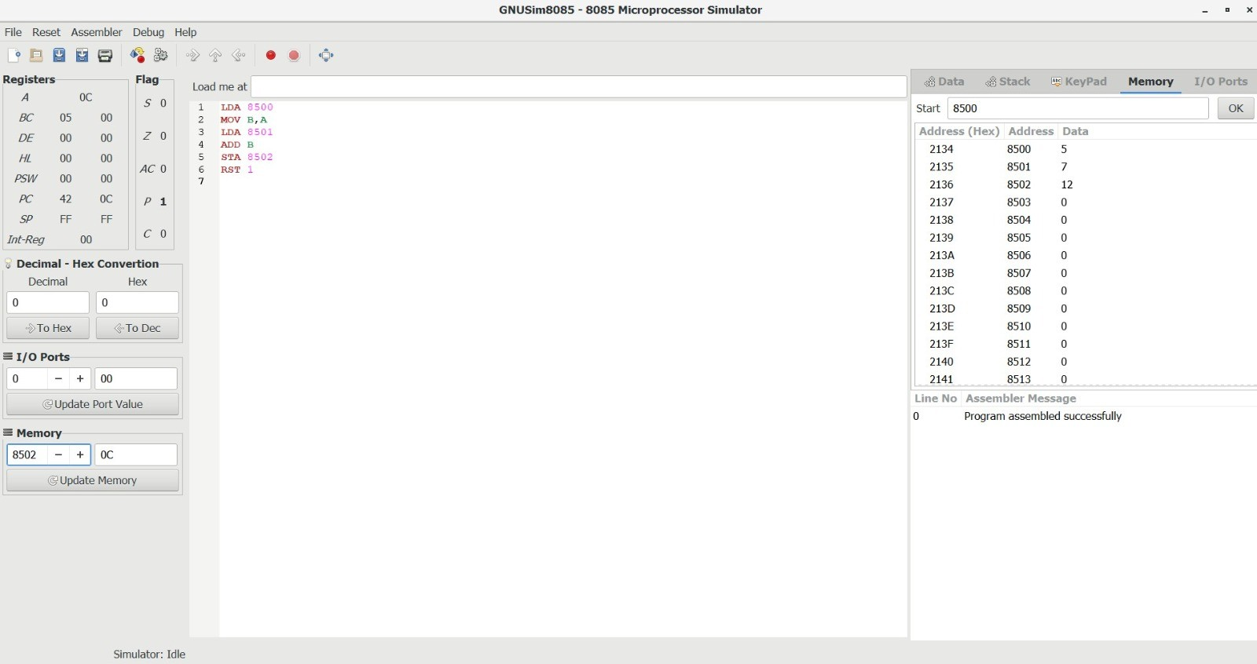

- 8 Bit Subtraction

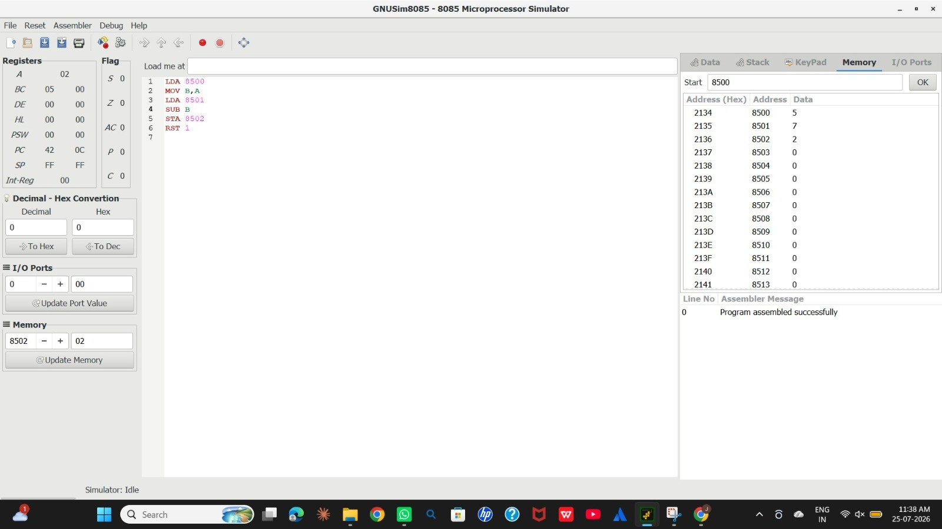

3) 8 Bit Add with carry
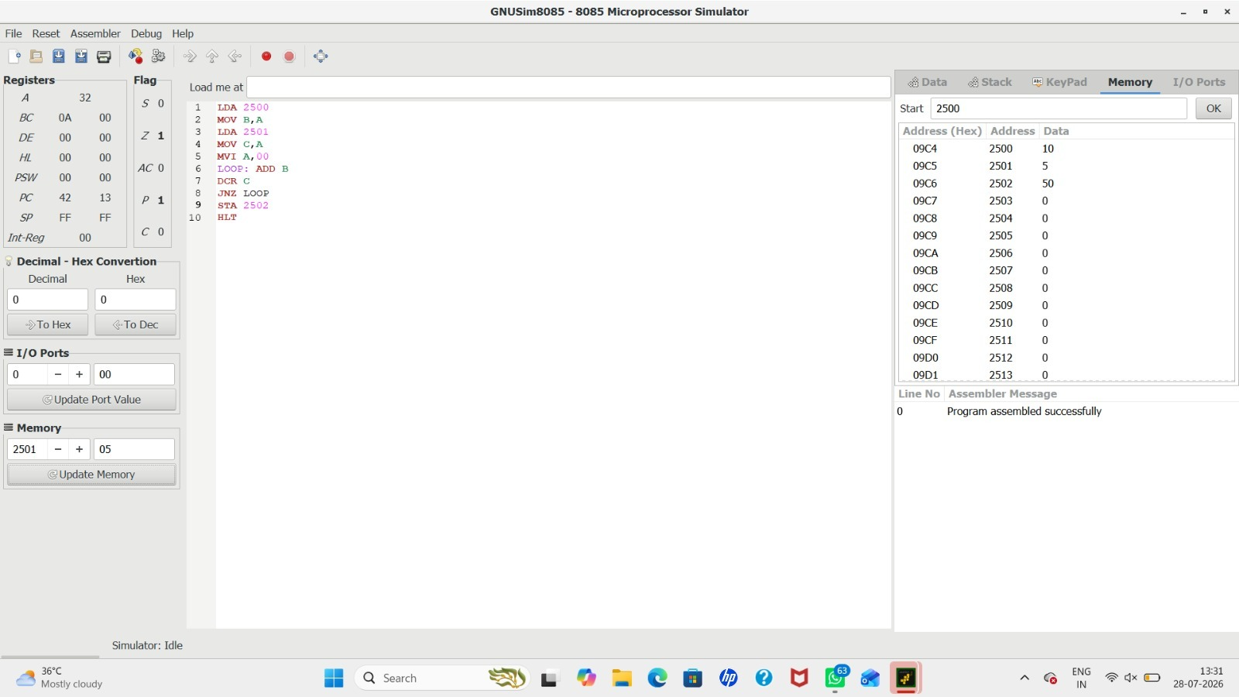

4) 8 Bit Sub with Borrow
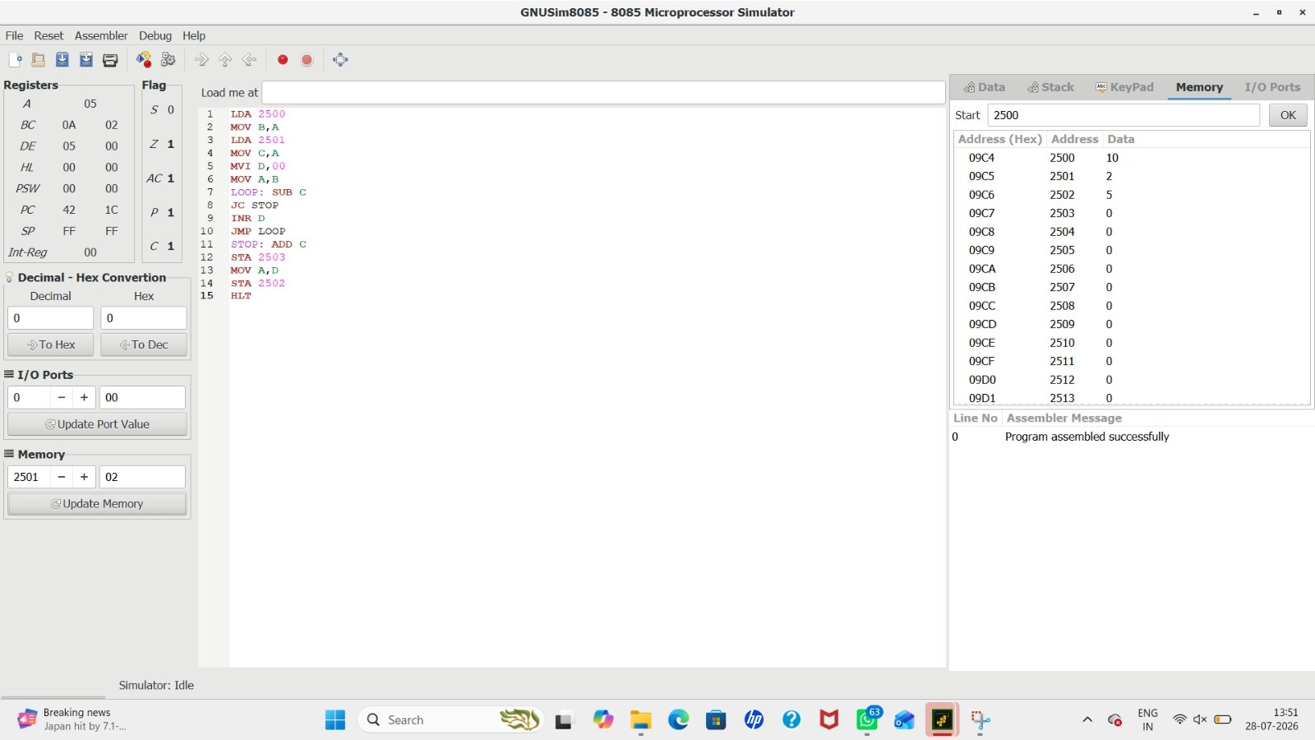

5) 8 Bit Multiplication


6) Division with Quotient
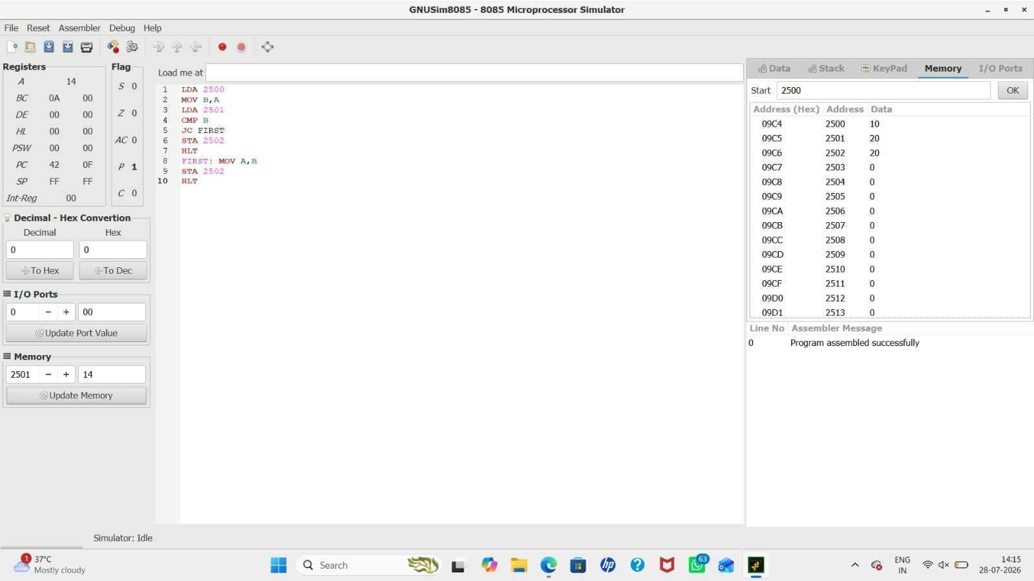

7) Division without Quotient


8) Greatest Of 2 Numbers
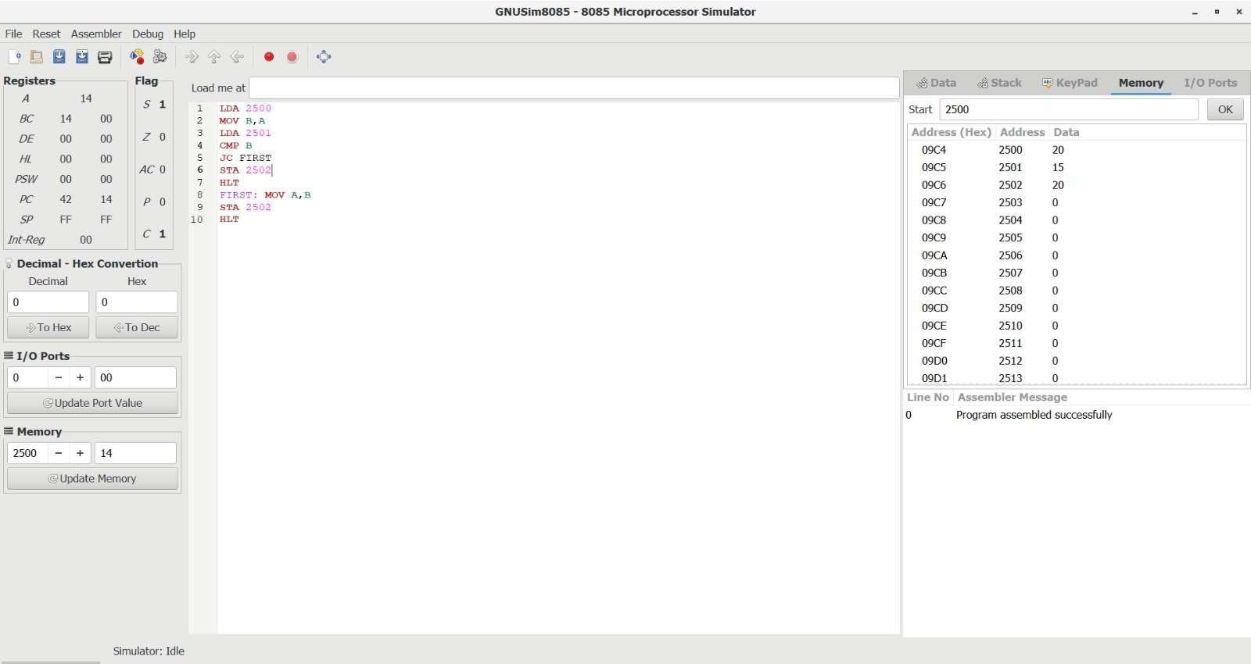

9) Smallest Of 2 Numbers
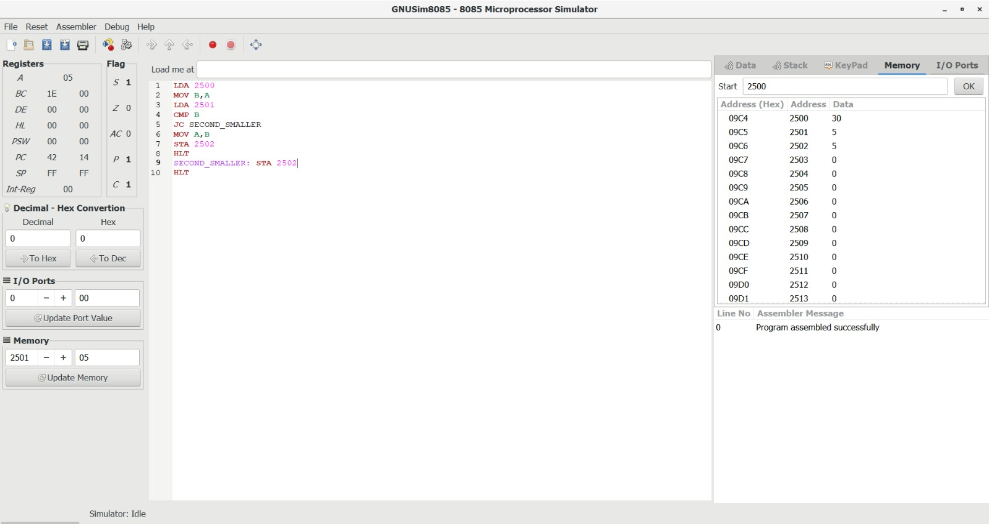

10) Swapping
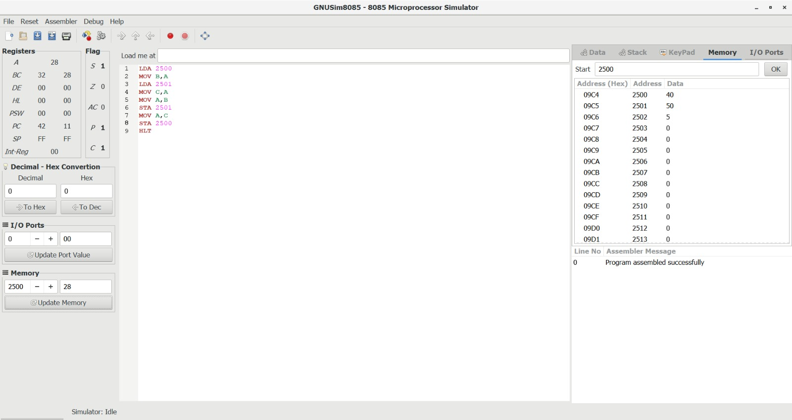

11) 1s Complement
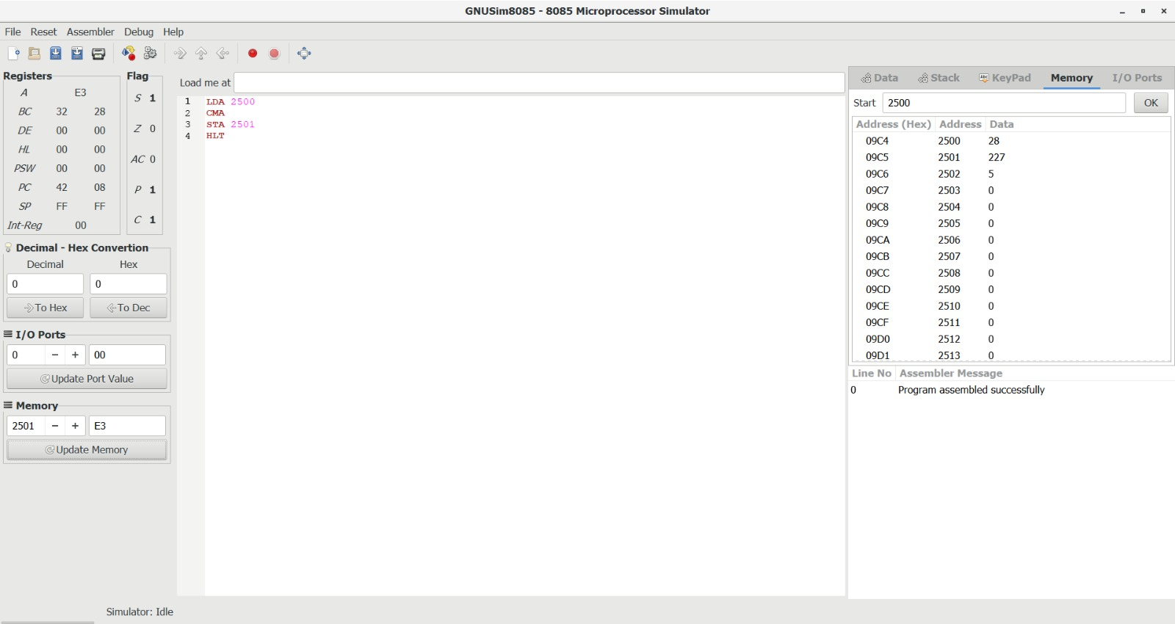

12) 2s Complement
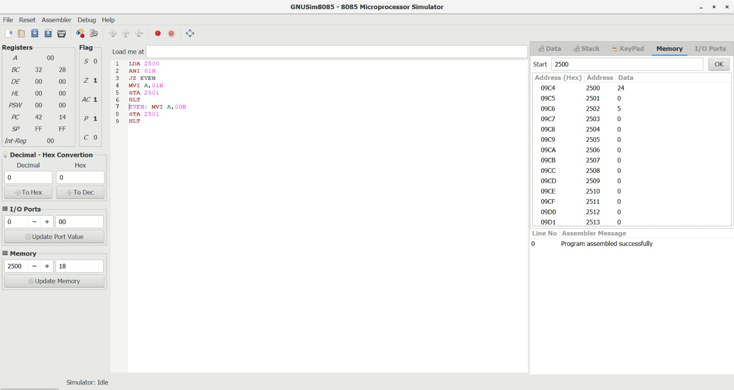

13) Odd/Even
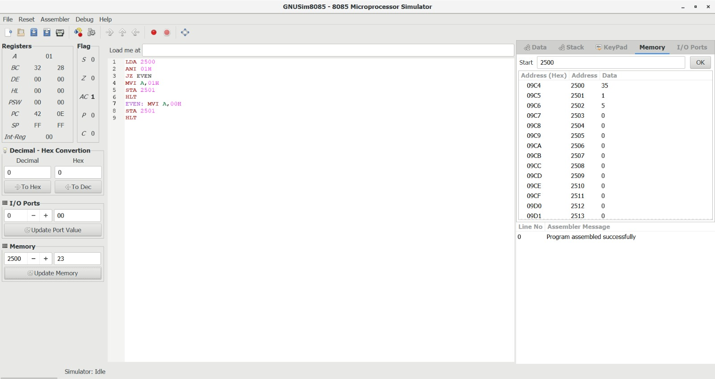

14) Positive/Negative
